**Department of**

**Computer Science and Engineering**

***Information Retrieval***

***CSE645***

***Assignment-1***

**20-marks lab component**

**Team member 1: Arun J Kennedy**

**USN: 1MS18CS029**

**Team member 2: Ashik MP**

**USN: 1MS18CS030**

**M S Ramaiah Institute of Technology, Bangalore**

**Department of Computer Science & Engineering**

**Bangalore - 560054, Karnataka, India**

Exercise 1: Implementation of Pre-processing of a Text Document.

**Aim:** Given a set of document, implement the preprocessing procedures and store the resulting file.

Exercise 2:

Exercise 3:

**Exercise 4:** Implementation of probabilistic Model.

Rank 10 documents for a given query.

**Aim:** Implement probabilistic model on a given set of 10 documents and Rank the documents for a given query.

**Steps to execute:**

*Step 1:* Preprocess the documents and obtain the inverted index for the files.

*Step 2:* Input the query from the user.

*Step 3:* Preprocess the query to obtain appropriate tokens to implement probabilistic model.

*Step 4:* Send the preprocessed query and the inverted index file into get_conditional_probability function to obtain a probability matrix.

*Step5:* Arrange the probabilities from the matrix obtained in descending order to get the Documents ranked from most relevant to least relevant.

**Code (python 3):**

import nltk  
import re  
from nltk.tokenize import RegexpTokenizer  
from nltk.corpus import stopwords  
from nltk.stem import PorterStemmer  
import pandas as pd  
  
xfiles = ['T1.txt', 'T2.txt', 'T3.txt', 'T4.txt', 'T5.txt', 'T6.txt', 'T7.txt', 'T8.txt', 'T9.txt', 'T10.txt']  
  
  
# Tokenizing the text, return token list  
  
  
def preprocess(sentence):  
 sentence = sentence.lower()  
 tokenizer = RegexpTokenizer(r'\w+')  
 tokens = tokenizer.tokenize(sentence)  
 return nltk.word_tokenize(" ".join(tokens))  
  
  
# Stopwords removal, return list  
def stop_words_remove(tokens):  
 stop = stopwords.words('english')  
 new_tokens = [i for i in tokens if i not in stop]  
 return new_tokens  
  
def remove_numbers(words):  
 *"""Replace all interger occurrences in list of tokenized words with textual representation"""* new_words = []  
 for word in words:  
 new_word = re.sub(r'\d+','',word)  
 if new_word != '':  
 new_words.append(new_word)  
 return new_words  
  
# Stemming of tokens, return list  
def stem_tokens(new_tokens):  
 ps = PorterStemmer()  
 stemmed = []  
 for i in new_tokens:  
 stemmed.append(ps.stem(i))  
 return stemmed  
  
  
inv_file = r'Inverted.csv'  
  
  
def get_relevance(n, nw):  
 return (n - nw + 0.5) / (nw + 0.5)  
  
  
def get_probability_matrix(n, df, toks):  
 prob_matrix = {}  
  
 for i in toks:  
 nw = df.loc[i, 'Occurences'].count(')')  
  
 prob_matrix[i] = [nw, get_relevance(n, nw)]  
 return prob_matrix  
  
  
def get_query_tokens(query):  
 tokens = preprocess(query.lower())  
 tokens = remove_numbers(tokens)  
 tokens = stop_words_remove(tokens)  
 tokens = stem_tokens(tokens)  
 return tokens  
  
  
def get_conditional_probability(qtok, inv_file):  
 prob_matrix = {}  
  
 df = pd.read_csv(inv_file)  
 toks = list(df['Tokens'])  
  
 df.set_index('Tokens', inplace=True)  
  
 word_matrix = get_probability_matrix(len(xfiles), df, toks)  
  
 # print(word_matrix)  
 for i in xfiles:  
 flag = False  
 val = 1  
 prob_matrix[i] = 0  
  
 for j in qtok:  
 if j in toks:  
 if i in df.loc[j, 'Occurences']:  
 flag = True  
 val *= word_matrix[j][1]  
 prob_matrix[i] = val if flag else 0  
  
 return prob_matrix  
  
  
print("Program 4: \n\tProbablistic Model Implementation")  
  
# print("Query : ")  
  
# kldsjflksajdk = get_query_tokens(input())  
print("Enter your query here :", end=" ")  
out1=get_query_tokens(input())  
print(out1)  
rel_docs = get_conditional_probability(out1, inv_file)  
  
rel_docs = {k: "{0:.5f}".format(v) for k, v in sorted(rel_docs.items(), key=lambda item: item[1], reverse=True)}  
  
# print(vect)  
print("The documents in the order of relevance to the query are as follows: ")  
print(pd.DataFrame(rel_docs.items(), columns=['File', 'Relevance']))

**input/output:**

Program 4:

Probabilistic Model Implementation

Enter your query here: Sunshine ten

The documents in the order of relevance to the query are as follows:

File Relevance

0 T7.txt 3.40000

1 T6.txt 1.00000

2 T1.txt 0.29412

3 T2.txt 0.29412

4 T3.txt 0.29412

5 T4.txt 0.29412

6 T5.txt 0.29412

7 T9.txt 0.29412

8 T10.txt 0.29412

9 T8.txt 0.00000

Process finished with exit code 0

**Inference/Conclusion:**

Probabilistic model is used in a corpus where the set of relevant documents for a query is predetermined and appropriate formula is applied to find the most relevant document for a given query.

**Exercise 5:** Implementation of various evaluation measures.

1. Calculate recall and precision values for all relevant documents and draw precision vs recall curve. Also calculate R-precision.
2. Compare performance of two IR algorithms for the same query q.
3. Calculate harmonic mean and E-measure (All three cases b=1, b>1, b<1)

**Aim:** To build a program that executes above tasks sequentially.

**Steps to execute (a):**

*Step 1:* Assume a set of relevant documents and a set of retrieved documents for a query q.

*Step 2:* Calculate the recall and precision value for each document in the retrieved set.

*Step 3:* Plot a curve with recall in x-axis and precision in y-axis using calculated values.

*Step 4:* Calculate the R-precision value which is equal to total documents in the retrieved set that belong to the relevant set divided by the total number of documents in the relevant set.

**Steps to execute (b):**

*Step 1:* Assume 5 queries were made with each query having it’s own set of relevant documents and the list of documents retrieved by the algorithm A and algorithm B.

*Step 2:* Calculate the R-precision value for each algorithm for each query.

*Step 3:* Subtract the R-precision value of algorithm B from algorithm A and store the value in an array X.

*Step 4:* Plot the array X into a histogram with x-axis being the query number and y-axis being R-precision A/B.

*Step 5:* If the sum of elements in array X is positive print algorithm A is better else print algorithm B is better.

**Steps to execute (c):**

*Step 1:* Assume a query for which relevant documents set and a list of Retrieved documents for an algorithm is available.

*Step 2:* Calculate the recall and precision for each document in the relevant set found in the retrieved list.

*Step 3:* Calculate the harmonic mean, E-precision for b value equal to 1 , 0.2 and 2 respectively and save the output in the form of a table.

**Code (python 3):**

import matplotlib.pyplot as plt  
# matplotlib.use("gtk")  
import pandas as pd

"""  
5.a : Recall Precision graph for the following relevant documents and documents retrieved  
  
Rq= {d3,d5, d9,d25,d39,d44,d56,d71,d89,d94,d105,d119,d124,d136, d144}  
Aq ={d123,d84,d56,d6,d8,d9,d511,d129,d187,d25,d38,d48,d250,d113 , d44,d99,d95,d214,d136,d39,d128,d71,d14,d5}  
  
"""  
# Relevant documents set  
# rq = [3,5,9,25,39,44,56,71,89,123]  
rq = [3, 5, 9, 25, 39, 44, 56, 71, 89, 94, 105, 119, 124, 136, 144]  
  
# Answer set  
  
aq = [123, 84, 56, 6, 8, 9, 511, 129, 187, 25, 38, 48, 250, 113, 44, 99, 95, 214, 136, 39, 128, 71, 14, 5]  
# aq = [123,84,56,6,8,9,511,129,187,25,38,48,250,113,3]  
  
# Recall list initialization  
recall = []  
  
# Precision list initialization  
precision = []  
  
rlen = len(rq)  
alen = len(aq)  
  
recallCount = 0  
  
# to keep track of the retrieved documents  
retrievedDocumentCount = 0  
# pc = 0  
  
rr = 0  
pr = 0  
  
for i in aq:  
 retrievedDocumentCount += 1  
 if i in rq:  
 recallCount += 1  
 rr = recallCount / rlen  
  
 pr = recallCount / retrievedDocumentCount  
  
 # print(rr,pp,recall_count,precision_count)  
 recall.append(rr * 100)  
 precision.append(pr * 100)  
  
print("\n\nThe R-precision value is :", rr)  
dashline = "\n\n---------------------------------------------------"  
print(dashline)  
  
plt.plot(recall, precision, color='orange')  
plt.title('Recall Precision curve')  
plt.xlabel('Recall')  
plt.ylabel('Precision')  
plt.xlim(0, 115)  
plt.ylim(0, 115)  
plt.show()

# 5.b: r-precision comparison for to different algorithms for 5 different queries  
  
algo_a = []  
algo_b = []  
  
  
def r_precision(a, b, r):  
 c1 = 0  
 c2 = 0  
 for i in a:  
 if i in r:  
 c1 += 1  
 for i in b:  
 if i in r:  
 c2 += 1  
  
 algo_a.append(c1 / len(a))  
 algo_b.append(c2 / len(b))  
  
  
# list of the 5 queries, relevant documents, documents retrieved by algorithm a and b respectively  
rel1 = [3, 5, 9, 25, 39, 44, 56, 71, 89, 123]  
algoA1 = [123, 84, 56, 6, 8, 9, 511, 129, 187, 25, 38, 48, 250, 113, 3]  
algoB1 = [12, 39, 13, 123, 8, 9, 19, 89, 87, 25, 70, 71, 29, 44, 3]  
  
rel2 = [3, 20, 5, 68, 51, 21, 27, 64, 6, 93]  
algoA2 = [3, 13, 5, 68, 51, 67, 32, 64, 45, 6, 94, 95, 93]  
algoB2 = [20, 30, 7, 78, 21, 27, 14, 15, 16, 6, 54, 4, 6]  
  
rel3 = [38, 65, 73, 88, 93, 74, 36, 4, 28, 30]  
algoA3 = [66, 88, 45, 43, 23, 12, 188, 200, 34, 4]  
algoB3 = [56, 73, 65, 3, 2, 99, 146, 93, 76, 74, 4]  
  
rel4 = [85, 95, 25, 64, 52, 12, 43, 18, 6, 66]  
algoA4 = [52, 62, 64, 77, 12, 45, 18, 43, 6]  
algoB4 = [95, 85, 25, 77, 123, 3213, 78, 18, 6]  
  
rel5 = [9, 76, 78, 31, 7, 47, 30, 8, 43, 51]  
algoA5 = [76, 75, 31, 7, 30, 44, 56, 50, 94, 223]  
algoB5 = [78, 9, 48, 47, 4, 31, 43, 56, 55, 99, 123, 222]  
  
  
r_precision(algoA1, algoB1, rel1)  
r_precision(algoA2, algoB2, rel2)  
r_precision(algoA3, algoB3, rel3)  
r_precision(algoA4, algoB4, rel4)  
r_precision(algoA5, algoB5, rel5)  
  
print('\n\n')  
print('algorithm a is better' if sum(algo_a) > sum(algo_b) else 'algorithms b is better')  
print(dashline)  
  
# algo_a = [0.3,0.6,0.3,0.5,1,0.78,0.24]  
# algo_b = [0.1,0.3,0.6,0.4,0,0.7,0.01]  
  
x = map(lambda a, b: a - b, algo_a, algo_b)  
x = list(x)  
  
fig = plt.figure(figsize=(10, 10))  
langs = [i for i in range(1, len(x) + 1)]  
  
plt.xlabel("Query Number")  
plt.ylabel("R Precision A/B")  
plt.title("Precision Histogram")  
  
plt.bar(langs, list(x), color='purple', width=0.5)  
  
plt.show()  
  
# 5.c : Harmonic Mean and E-Measure  
  
Rq = ['d3', 'd5', 'd9', 'd25', 'd39', 'd44', 'd56', 'd71', 'd89', 'd123']  
A1 = ['d123', 'd84', 'd56', 'd6', 'd8', 'd9', 'd511', 'd129', 'd187', 'd25', 'd38', 'd48', 'd250', 'd113', 'd3']  
  
  
def calhme(Rq, Aq):  
 rel_doc_count = 0  
 rn = len(Rq)  
 recall, precision, harmonic_mean, em1, em2, em0 = {}, {}, {}, {}, {}, {}  
  
 for i in range(len(Aq)):  
 if Aq[i] in Rq:  
 rel_doc_count += 1  
 recall[Aq[i]] = (round(rel_doc_count / rn, 2))  
 precision[Aq[i]] = (round(rel_doc_count / (i + 1), 2))  
 harmonic_mean[Aq[i]] = round(2 / ((1 / recall[Aq[i]]) + (1 / precision[Aq[i]])), 2)  
 em0[Aq[i]] = round(1 - harmonic_mean[Aq[i]], 2)  
 # Set b=2 for E-Measure  
 b = 2  
 em1[Aq[i]] = round(1 - ((1 + (b ** 2)) / (((b ** 2) / recall[Aq[i]]) + (1 / precision[Aq[i]]))), 2)  
  
 b = 0.2  
 em2[Aq[i]] = round(1 - ((1 + (b ** 2)) / (((b ** 2) / recall[Aq[i]]) + (1 / precision[Aq[i]]))), 2)  
  
 else:  
 pass  
  
  
 return pd.DataFrame({'Recall': pd.Series(recall), 'Precision': pd.Series(precision), 'Harmonic mean': pd.Series(harmonic_mean),  
 'E-Measure (b=1)': pd.Series(em0), 'E-Measure (b>1)': pd.Series(em1),  
 'E-Measure (b<1)': pd.Series(em2)})  
  
  
# Harmonic Mean and E-Measure  
resultDataframe = calhme(Rq, A1)  
print()  
print()  
print(resultDataframe)  
# resultDataframe.to_csv('5(c).csv')

**Input/output:**

1. ***Console output:***

The R-precision value is : 0.5333333333333333

---------------------------------------------------

algorithms b is better

---------------------------------------------------

Recall Precision ... E-Measure (b>1) E-Measure (b<1)

d123 0.1 1.00 ... 0.88 0.26

d56 0.2 0.67 ... 0.77 0.39

d9 0.3 0.50 ... 0.67 0.51

d25 0.4 0.40 ... 0.60 0.60

d3 0.5 0.33 ... 0.55 0.67

[5 rows x 6 columns]

Process finished with exit code 0

***Graph output:***

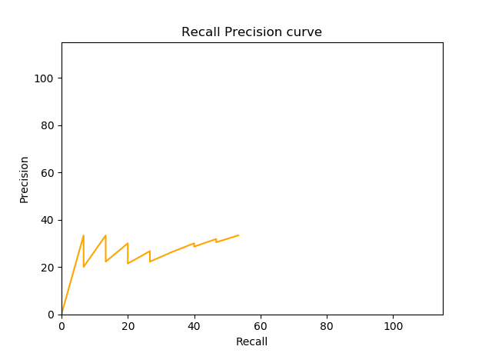

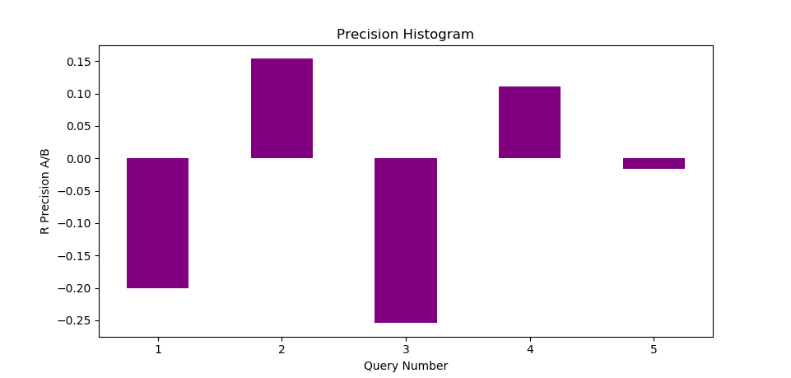

***Saved table:***

|  |  |  |  |  |  |  |
| --- | --- | --- | --- | --- | --- | --- |
|  | Recall | Precision | Harmonic mean | E-Measure (b=1) | E-Measure (b>1) | E-Measure (b<1) |
| d123 | 0.1 | 1 | 0.18 | 0.82 | 0.88 | 0.26 |
| d56 | 0.2 | 0.67 | 0.31 | 0.69 | 0.77 | 0.39 |
| d9 | 0.3 | 0.5 | 0.37 | 0.63 | 0.67 | 0.51 |
| d25 | 0.4 | 0.4 | 0.4 | 0.6 | 0.6 | 0.6 |
| d3 | 0.5 | 0.33 | 0.4 | 0.6 | 0.55 | 0.67 |